PSRA RULE BOOK

THE PREPARATORY SCHOOLS RIFLE ASSOCIATION

President. Jonathan Hammond.

Vice President. Major M.E.H. Pardoe.

Chairman . C.H. Laughton. St. Andrew's Eastbourne.

Interim Treasurer. C. H. Laughton.

Secretary. Mary Eveleigh.

Committee. A.R. Penfold, Tonbridge School.

Correspondence should be addressed to:

Mary Eveleigh, PSRASecretary@gmail.com

The committee is anxious to help members, or those considering membership, and we will do our best to provide advice or information on any shooting matter.

The Association was formed in 1906. A short history of the PSRA (including results) was published in 1994. There is also a PSRA History detailing the results of all the competitions over the last 100 years – published in 2006. Copies of both publications are available from the Secretary at the above address.

Revised August 2012.

BOOK CONTENTS

SECTION TITLE PAGE
1 Organisation of the PSRA. 3
2 General Rules for all Competitions. 4
3 Special Rules for .22 Rifle Competitions. 8
4 Special Rules for Air Rifle Competitions. 10
5 Special Rules for Air Pistol Competitions. 11
6 Divisions. 13
7 Proficiency Certificates. 14
8 The NSRA. 15
9 Contact Addresses and Phone numbers. 16
10 Attached Appendices.
Advice sheets on the following topics :

1. How to start shooting. 17

2. Rules for a .22 Rifle Range. 18

3. Rules for an Air Rifle Range. 19

4. Rules for an Air Pistol Range. 20

5. Shooting Law as it applies to minors. 22

6. Protection from deafness on .22 Rifle ranges. 23

7. Application for a certificate as Range Officer. 24

1. The Organisation of the PSRA.

  - The object of the Association is to encourage target shooting in Preparatory Schools for both boys and girls.

  - Membership is open to Schools which belong to the Incorporated Association of Preparatory Schools. Associate membership also exists and Non-IAPS Schools with pupils aged under 14 can apply for this.

1.3 The Management of the affairs and funds of the Association is entrusted to a Committee which is elected annually by the members. The Committee shall interpret the Rules and submit for approval of members any change which is thought desirable.

The Committee shall appoint an Honorary Treasurer.

1.4 An Annual General Meeting is arranged, usually in the Easter holiday, at which the Committee is elected. Any nominations must reach the Secretary by 1st February and will be published in the convening notice of the AGM. Postal votes are admissible. Should a vacancy occur, the Committee may co-opt a member to serve until the next A.G.M.

1.5 The Annual Subscription is decided at each A.G.M. for the following year. Cheques should be made payable to the 'Prep Schools Rifle Association'. Please write the name of the School on the back and send it to the Honorary Treasurer, (C.H. Laughton). Payment can also be made by BACS.

1.6 Safety. The paramount consideration in all forms of shooting is SAFETY. To this end, the person in charge of the firing point - the Range Officer - must be qualified, over the age of 21 and approved by the Headmaster. The minimum qualification is the NSRA’s basic Range Control Certificate.

Please apply in the first instance to the Secretary, PSRA. There are equivalent qualifications within the Armed Forces and Police and these are, of course, acceptable. However, it is suggested that details of such qualifications are verified.

Furthermore, it should be appreciated that supervising and coaching shooting (all disciplines) in Prep Schools is different from dealing with older and more mature pupils. It is therefore recommended that those who have not served in a Prep School before, spend at least one term in company with a qualified coach ( in the range that the School uses) before assuming the responsibility in that range.

Schools who shoot .177 air pistols are strongly urged to read Appendix 4, Rules for an Air Pistol Range, and give particular consideration to the material used to the surrounding of their pellet catchers. There is a much greater risk of pellet ricochet when air weapons are used at short distances. The wearing of suitable eye protection is strongly advised.

  - Further Qualifications. The NSRA also offers courses for those seeking higher qualifications. Please see page 17 for their address.

2. General Rules for All Competitions.

The PSRA competitions, and events run under PSRA rules, are restricted to Schools with full PSRA membership.

Special rules which apply to .22 rifle, air rifle, and air pistol competitions are shown separately.

2.1 The Trophies available are: See page 8 for photographs.

For .22 rifle at 20 or 25 yards......................... St. Patrick's Shield with the Lord Robert's Cup, St. Hubert's
Trophy, Pardoe Cup ( Under 12 Cadet Pair) and Hammond
Cup (Supported shooting).

at 50 yards or 50 metres....................... St. George's Shield.

For .177 air rifle at 10 yards ....................... St. David's Shield with the Lord Robert's Bowl, the Sawyer
Cup and the Mostyn House Cup (Under 12 Cadet Pair).

For .177 air pistol at 6 yards ..................... St. Andrew's Shield.

All these trophies are competed for three times a year except the St. George's Shield which is shot for just once in the Summer term.

The St. Hubert's Trophy and the Sawyer Cup are awarded to the schools which come second in the St. Patrick's and the St. David's Shields. If the same school provides the first two (or more) teams these trophies are awarded to the next school on the list.

The Lord Roberts Trophies are awarded to the highest scoring 2nd VIII’s in both the St. Patrick's Shield and St. David's Shield competitions. The Pardoe cup is awarded to the highest scoring Cadet pair combination. This is strictly limited to pupils aged Under 12 (on the day of firing). Similarly, the Mostyn House Cup is awarded to the highest scoring Cadet pair in the Air rifle competition.

The Hammond Cup is awarded to the school with the highest score achieved by supported shooting.

A system of Divisions (see Section 6) is used in the St. Patrick's Shield and St. David's Shield competitions, for which the Lord Lloyd Shields are awarded.

2.2 Teams. Schools may enter one or more teams of eight pupils for the St Patrick’s and St David’s shield competitions and of four pupils for the St Andrew’s and St George’s shield competitions and also the Hammond Cup. Each competitor must be under 14 on the day of firing the match card (excepting the Cadet pair category which is for pupils aged Under 12).

If a School's nominated first or second team is beaten by its own second team or other team, the best team score from that School is counted as its first team, the team having the second best score being counted as its second team.

2.3 Place, Date and Stickers. Any convenient range may be used, although for .22 rifles the range must have a valid Range Safety Certificate (issued by the NSRA) Shooting may begin as soon as the competition stickers are received (see below) and schools may arrange for the match to be shot on any day or days that they please. For the final date see 'Results' (2.7) and for air pistol see (5.6).
For almost all competitions, schools will be sent special stickers which should be attached to the back of each match target fired. The sticker must be stuck to the relevant target before firing commences. The only exception is for the St Andrew’s shield competition ( .177 air pistol) where targets (with stickers attached) are sent out to the schools wishing to enter. For practice targets see Sections 3.1 and 4.1.

Schools wishing to compete should contact the Competitions Secretary in order to obtain stickers detailing which competitions they would like to enter and how many teams.

Any unused stickers should be returned to the PSRA Competitions Secretary by the end of the term for which they were issued.

2.4 Conduct of the Match. The distance of a range is measured from the forward edge of the firing point to the target face. Coaching, spotting and sighting shots on another target are permitted. If time does not allow a competition shoot to be completed in one session, the second session may (at the discretion of the coach) be preceded by sighting shots. Particular attention is drawn to the rules regarding position and sights in the Special Rules, sections 3.2 & 4.2. All match cards must be signed by the competitor and witnessed by the coach before sending them to the Competitions Secretary.

It is possible to amend the rules about position to enable a disabled shooter to take part. The circumstances in each case should be referred to the Secretary.

2.5 Scoring. The value of a shot is decided by the edge of the shot hole nearest the centre of the target, ie inward gauging. All scoring lines are a part of the higher scoring area they enclose and when the flange of a shot gauge touches the line, the higher value will be credited; however, only the Competitions Secretary may use a gauge on the competition targets. A doubtful shot should be scored in pencil on the register. No allowance can be made for a round which goes off by mistake or for a defective rifle, cartridge or pellet. If the bullet of a defective cartridge does not leave the barrel another cartridge may be used once the barrel is clear.

2.6 Misplaced shots. A competitor who fires in error on another competitor's card shall be allowed the value of the shot less two points for each misplaced shot. See also 3.1 and 4.1.

2.7 Results. The completed score registers and ALL targets must reach the Competitions Secretary by midnight on the 23rd November, 2nd March or 8th June. The only exception is for the St Andrew’s Shield competition which has the following deadlines, 15th December, 25th March and 10th July..
Entries which are late arriving or mislaid in the post will be excluded. Scores sometimes go astray in the post and we recommend the use of recorded delivery. Please write the initials and names of the team members in clear capitals on the score registers. The address of the Competitions Secretary is shown on the score registers sent with the competition targets.

It is of paramount importance that the score and targets reach the competitions secretary by the date stated. It would be very helpful to post your entries early since the time the Secretaries give to PSRA work is additional to their usual teaching / work commitments. In extra-ordinary circumstances please contact the competition's secretary before the deadline; it is just possible he may be able to grant an extension.
  - Miniature shields and Winners' cards. PSRA miniature shields are available to purchase for individuals who score as follows.

St. Patrick's Shield - 98 or more
St. David's Shield - 90 or more
St. George's Shield - 180 or more aggregate score
St. Andrew's Shield - 95 or more

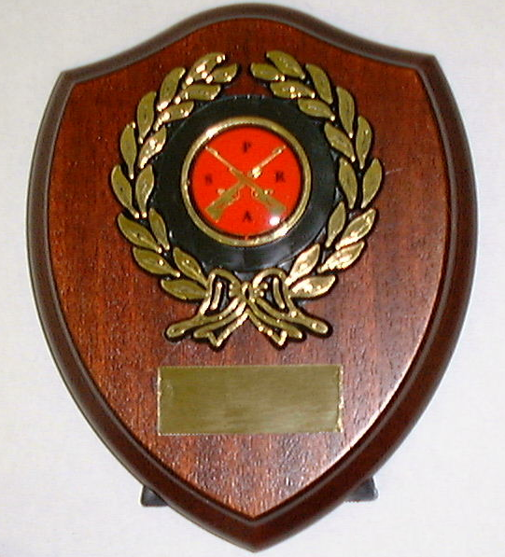
They come in two sizes in both rifle and pistol designs.
4 inch shield with crosses rifles.
4 inch shield with pistol centre.
5 inch shield with crossed rifles.
(Below)
Winners' Certificates are awarded to all members of a team which wins any trophy.

2.9 Trophies. The trophies are held by the winners for one term, except the St. George's Shield, which is held for one year. The results list will inform holding Schools of the details of the new winner. The trophy must then be sent WITHOUT DELAY to the next School. The Major shields, The Lord Robert's Cup and The Lord Robert's Bowl must be sent by Securicor or another suitable courier firm. Other trophies, ie St. Hubert's Trophy, Sawyer Cup, Hammond Cup and the Lord Lloyd shields should be sent by post, preferably by recorded delivery.

Schools which have won a trophy may have it engraved at their own expense if there is still space available on it. If the trophy is found to be damaged, please inform the Chairman at once.

Trophy photos……Left to right:
The St Andrew’s Shield (Air pistol), The St Patrick’s Shield, The Lord Roberts Cup and The St George’s Shield (.22 Rifle).
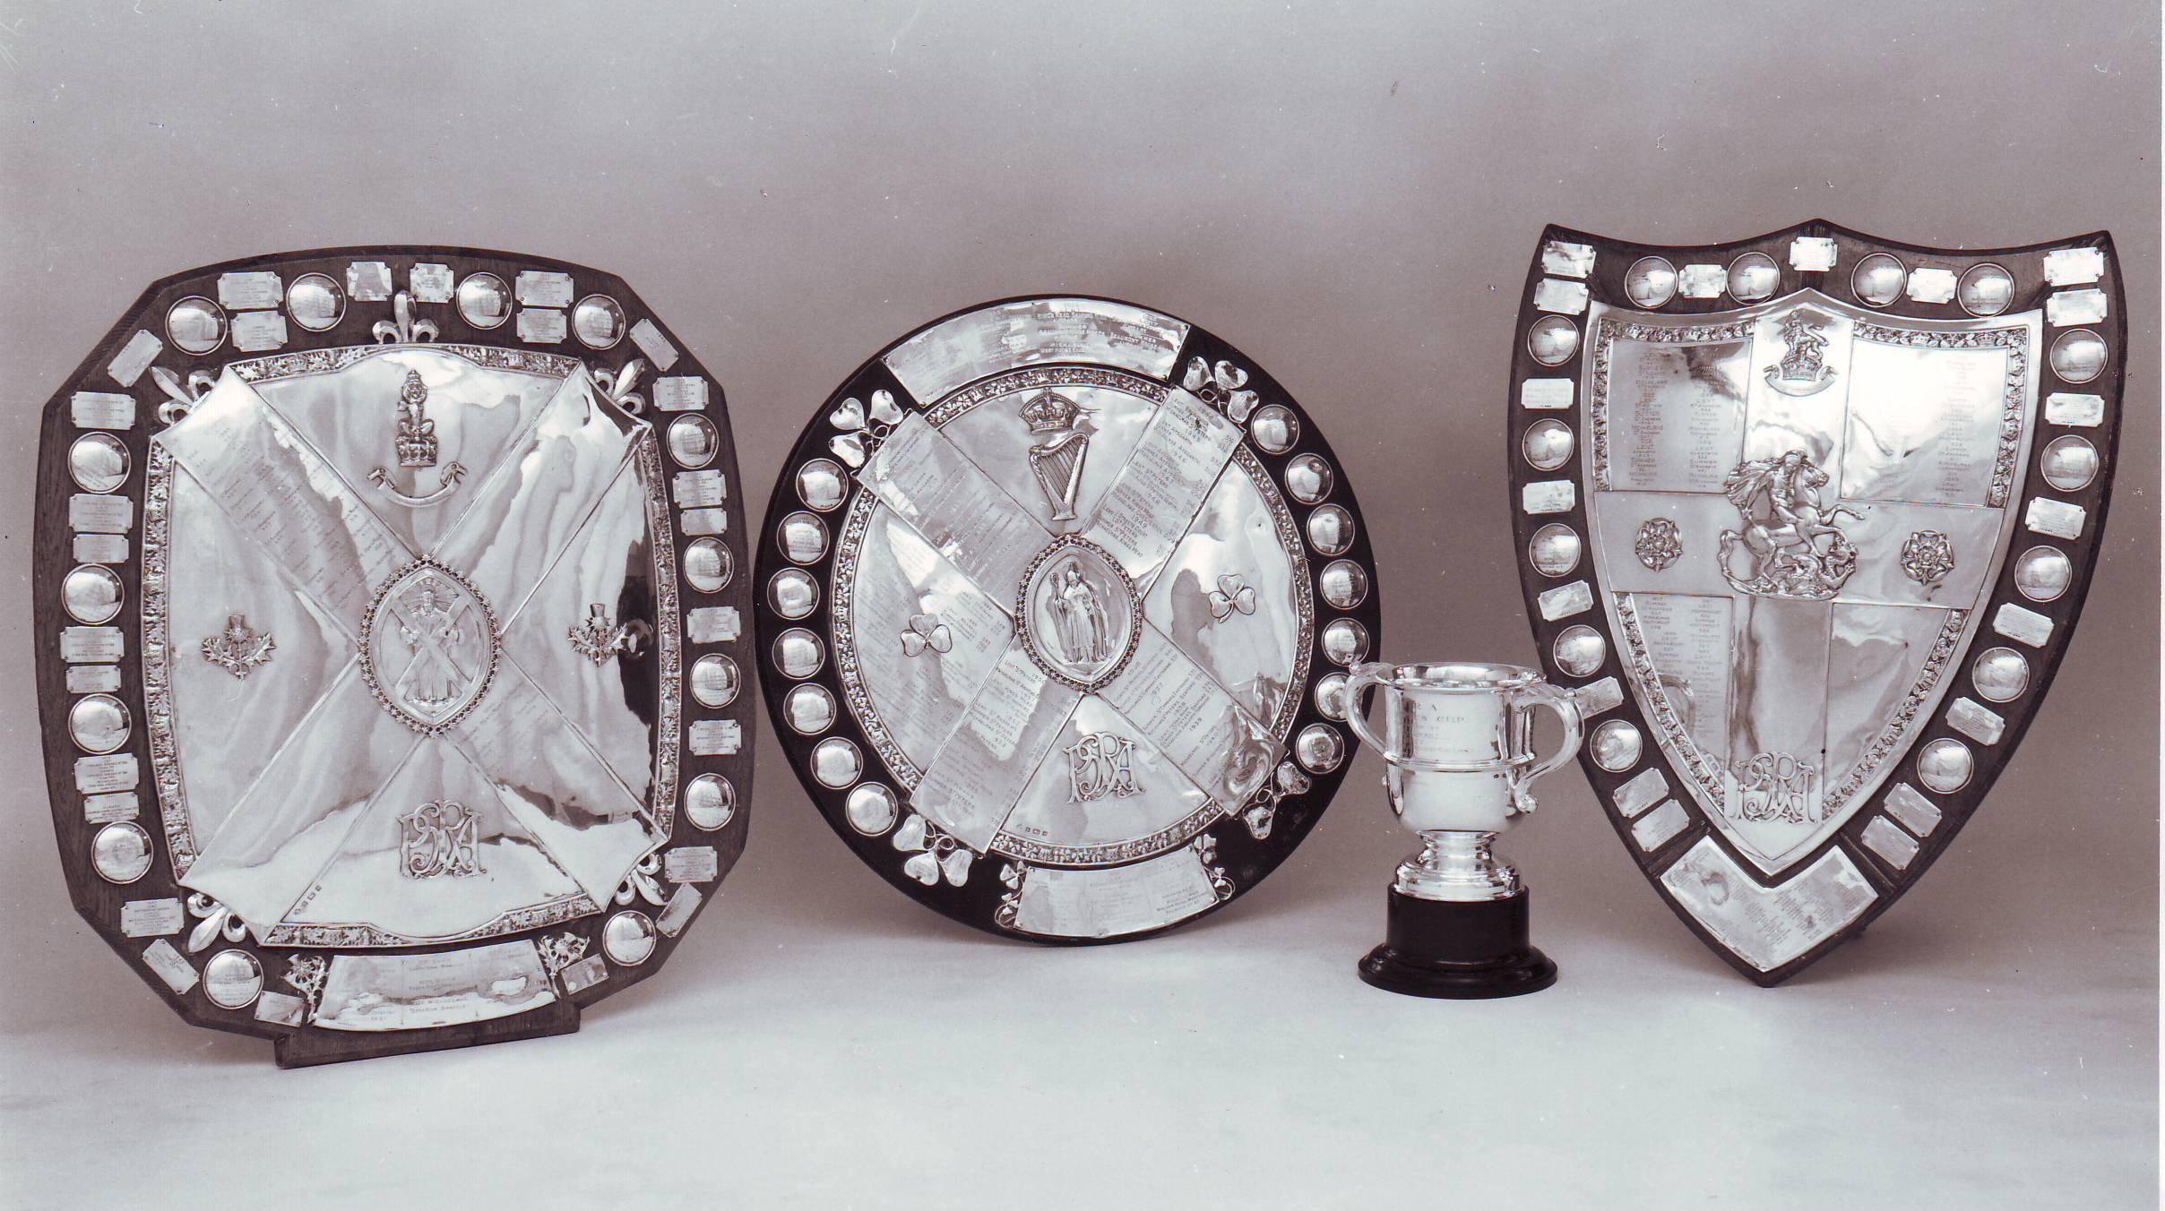
The Lord Roberts Bowl and The St David’s Shield (.177 air pistol).

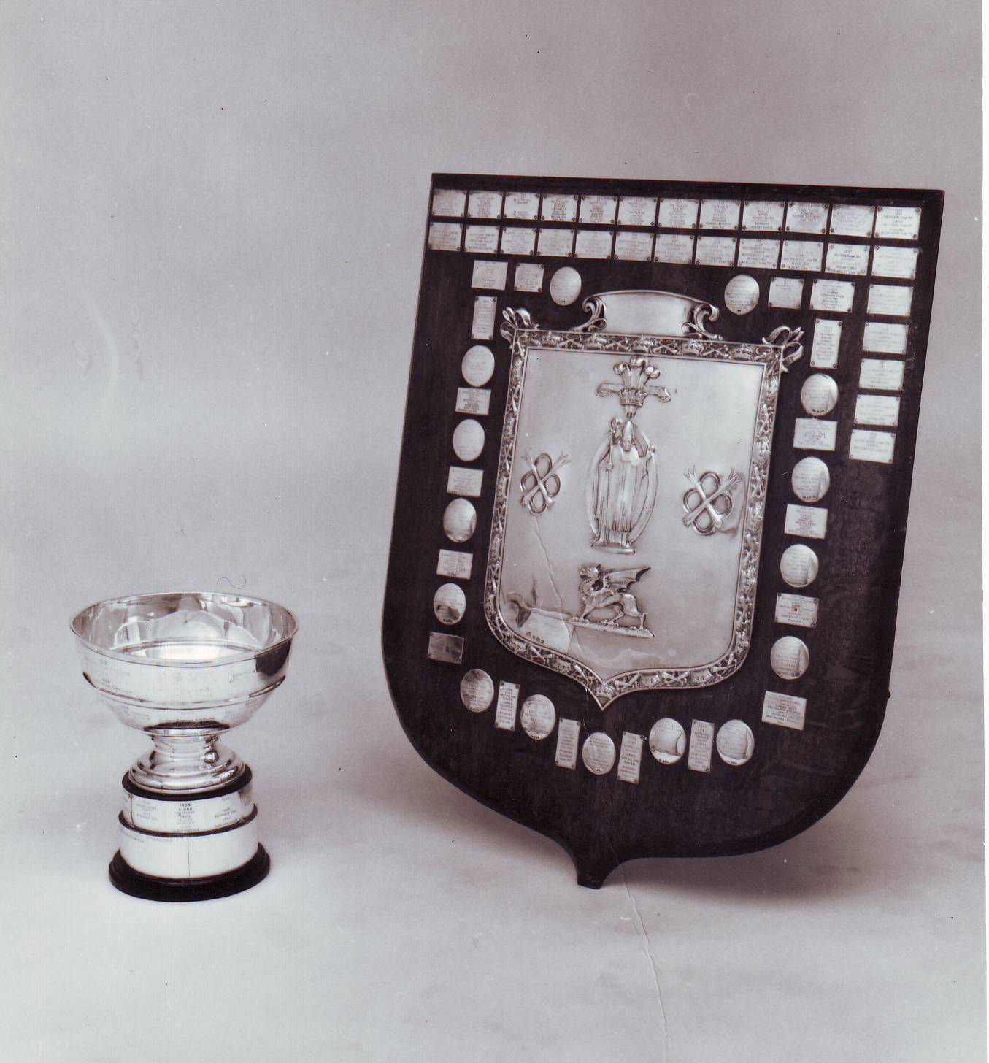
3. Special rules for .22 rifle competitions.

The following trophies are awarded:

The St. Patrick's Shield at 20 or 25 yards, the St. Hubert's Trophy for the school which comes second, the Lord Roberts Cup for the best placed 2nd VIII, the Pardoe Cup for the best Cadet Pair (aged under 12) and the Hammond Cup. The St. George's Shield, shot before the summer term deadline, at 50 metres on an electronic target ( Eg Malcolm Cooper Range at Bisley) or 50 yards.

3.1 Targets and scores. The decimal targets used are:

2005CS 20 yards 5 target 'Match'
2505CS 25 yards 5 target 'Match'
5002BM 50 yards 2 target 'Match'
At Bisley, the electronic ISU 50 metre (1989) target is used.
Targets for practice may be had from the NSRA, who can also supply a single target practice card (2001CS or 2501CS) (see section 9).

Ten consecutive shots must be fired at the card, two shots being fired at each of the five targets. If more than the correct number are fired at a target, but the total of shots on the card is still 10, then all shots score but one point is deducted for each misplaced shot. If there are more than 10 shots on the card, the 10 lowest-scoring shots are counted.
Tied scores will be decided by, first, the number of '10's scored and, secondly, graduated gauges.

3.2 The Rifle and Position. Any miniature rifle of .22 calibre may be used. The trigger pull should not be less than 0.5kg, but the need for safety is the over-riding requirement. The rifle may have any pattern of sights, fixed or adjustable, but it may not be fitted with lenses tube foresights or telescopic sights. Tinted plane filters may be used.

The prone position will be used without rests of any kind. Slings, padded jackets, elbow pads and gloves may be used but the forearm, hand, rifle ( in particular the butt) or sling must not touch the ground. The pupil must load the rifle themselves; no other person may do this for them. The only exception is for the Hammond Cup in which the rifle may be used “supported” with a rest.

The following photo shows the rifle butt in the correct position ie not touching the ground.

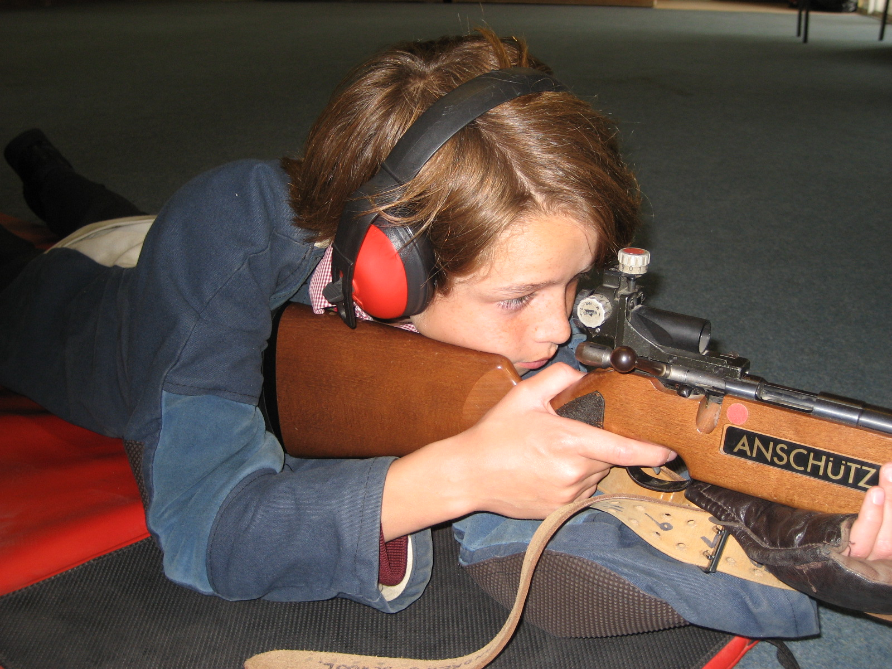

The following photo shows an unacceptable position ie with the rifle butt too low.

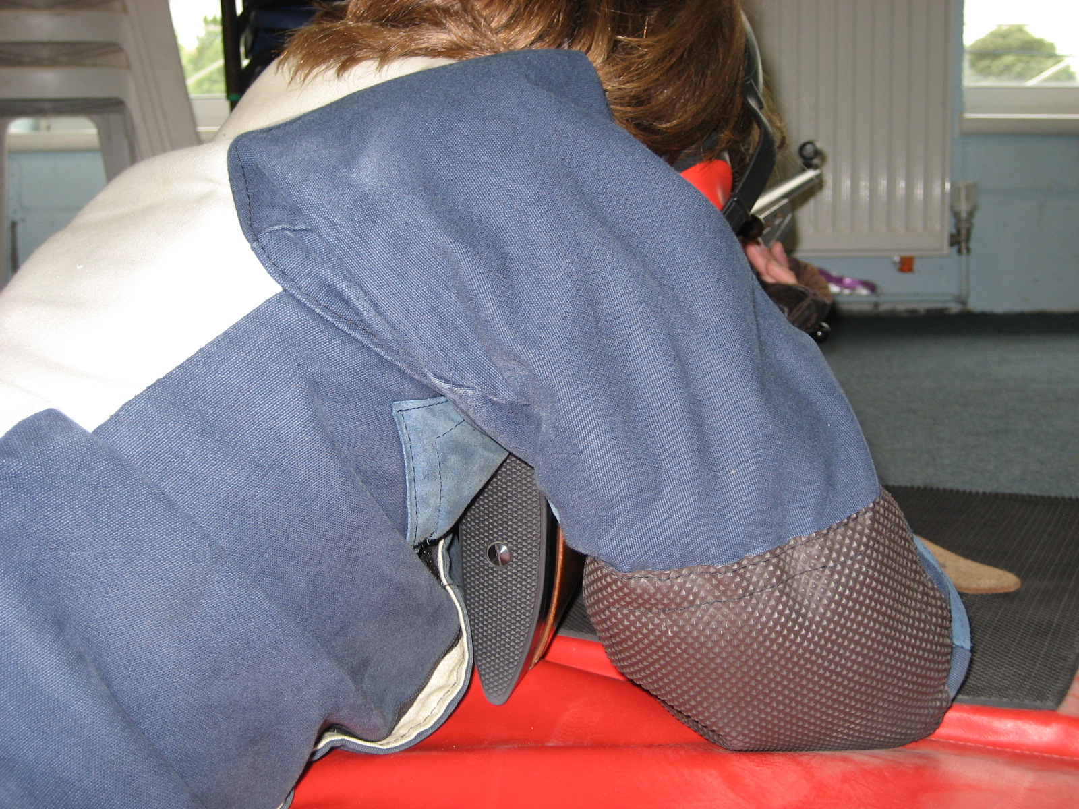

3.3 Ear protectors. These MUST be worn by ALL competitors taking part in matches or certificates under PSRA conditions. The Association most strongly recommends that they should be worn at ALL times on the range. Failure to do so can result in the early onset of 'Noise induced hearing loss' for which there is no cure.

3.4 Home Office Approval. This is necessary for schools using .22 rifle ranges. Form 124 should be obtained from the Home Office which will also advise of the criteria required for approval to be granted. The form can be downloaded from the internet at the following address www.homeoffice.gov.uk

3.5 St George’s Shield. Targets are the electronic 50 metre (ISU) type at Bisley. Schools who compete should get their scores verified by a suitable witness and send the print out for each competitor to the Competitions Secretary. Schools shooting in the summer term should use 5002 BM ( 50 yard ) targets with stickers (on the back) in the usual way. In each case, teams should comprise 4 persons. 20 consecutive shots should be fired by each competitor.

- Special rules for Air Rifle Competitions.

The following trophies are awarded: the St. David's Shield for the winners, the Sawyer Cup for the school which comes second, the Lord Roberts Bowl for the best-placed 2nd VIII and the Mostyn House Cup for the highest scoring Cadet Pair (Under 12).

4.1 Range, Targets and scoring. The range is 10 Metres. The targets used are the NSRA's air 3/89 type. Only this type may be used - not photocopies or reprints. Targets for practice may be ordered from the NSRA.

Flat-headed pellets must be used for competitions. 10 shots are fired in all: 2 shots at each “diagram”. If more than 10 shots are fired at a target, the 10 lowest-scoring shots are counted.

In the case of a tie the number of bulls scored will be used to adjudge the winning team.

4.2 The Rifle and position. Any air rifle of .177 calibre with aperture sights may be used. Air rifles of .22 calibre are not allowed, nor are telescopic sights. Air rifles with open sights may also be used. Foresight protectors may be used.

The prone position will be used without rests of any kind. The forearm, hand or rifle – in particular the butt - must NOT touch the ground. Slings ,shooting jackets and gloves may be used.

5. Special rules for Air pistol Competitions.

The following trophy is awarded: The St. Andrew's Shield.

The organiser is : C.H. Laughton. His address is St Andrew’s School, Meads, Eastbourne, BN20 7RP.

5.1 Teams. Schools may enter any number of teams comprising four pupils in each.

5.2 Targets. The targets used are the NSRA ‘AIR 4/89’. For the NSRA’s address, see section 9.

5.3 Pistols and Ammunition. Any spring or pneumatic - powered .177 pistol that does not require a Firearms Certificate may be used provided that it has a post or blade foresight and that it has fixed grips, no part of which may encircle the hand or hands holding it. Correcting lenses may not be used. Flat - headed pellets must be used.

5.4 Range. The distance is 6 yards, measured from the target face to the foremost point where the firer may place his foot. This point should be marked on the floor and a table or bench should be placed in front of the firer. The firer may not touch this table with any part of the body when in the firing position. It is advised that the bottom of the target should be so placed that it is 4 feet from the floor.

5.5 Firing position. The orthodox hold for a pistol will be used. This is to grip the pistol with one or both hands at arm's length, with the elbows clear of the body. No part of the hand should be in front of the trigger guard. No glove, mitt or other hand or arm support may be used.

The following photos illustrate these points.

An acceptable position with the elbows clear of the body and the hands in the correct position….

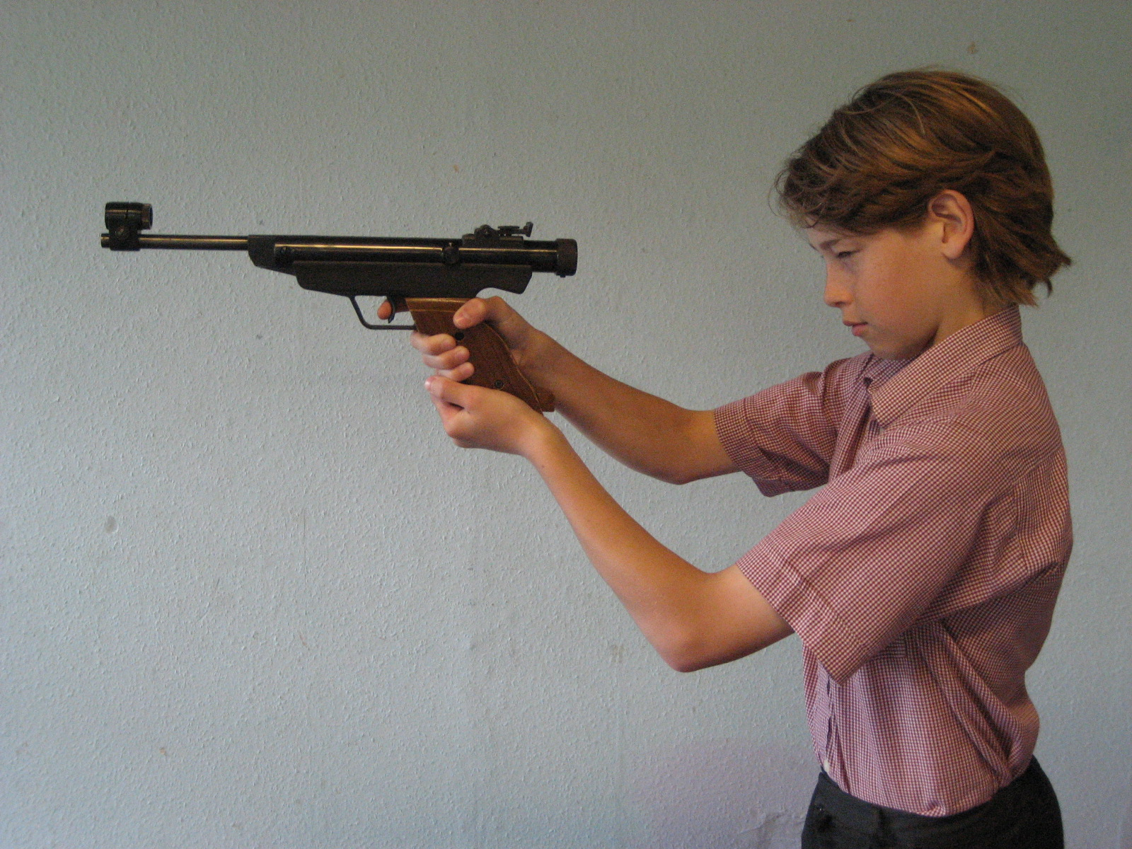

An unacceptable position with the elbows touching the body….
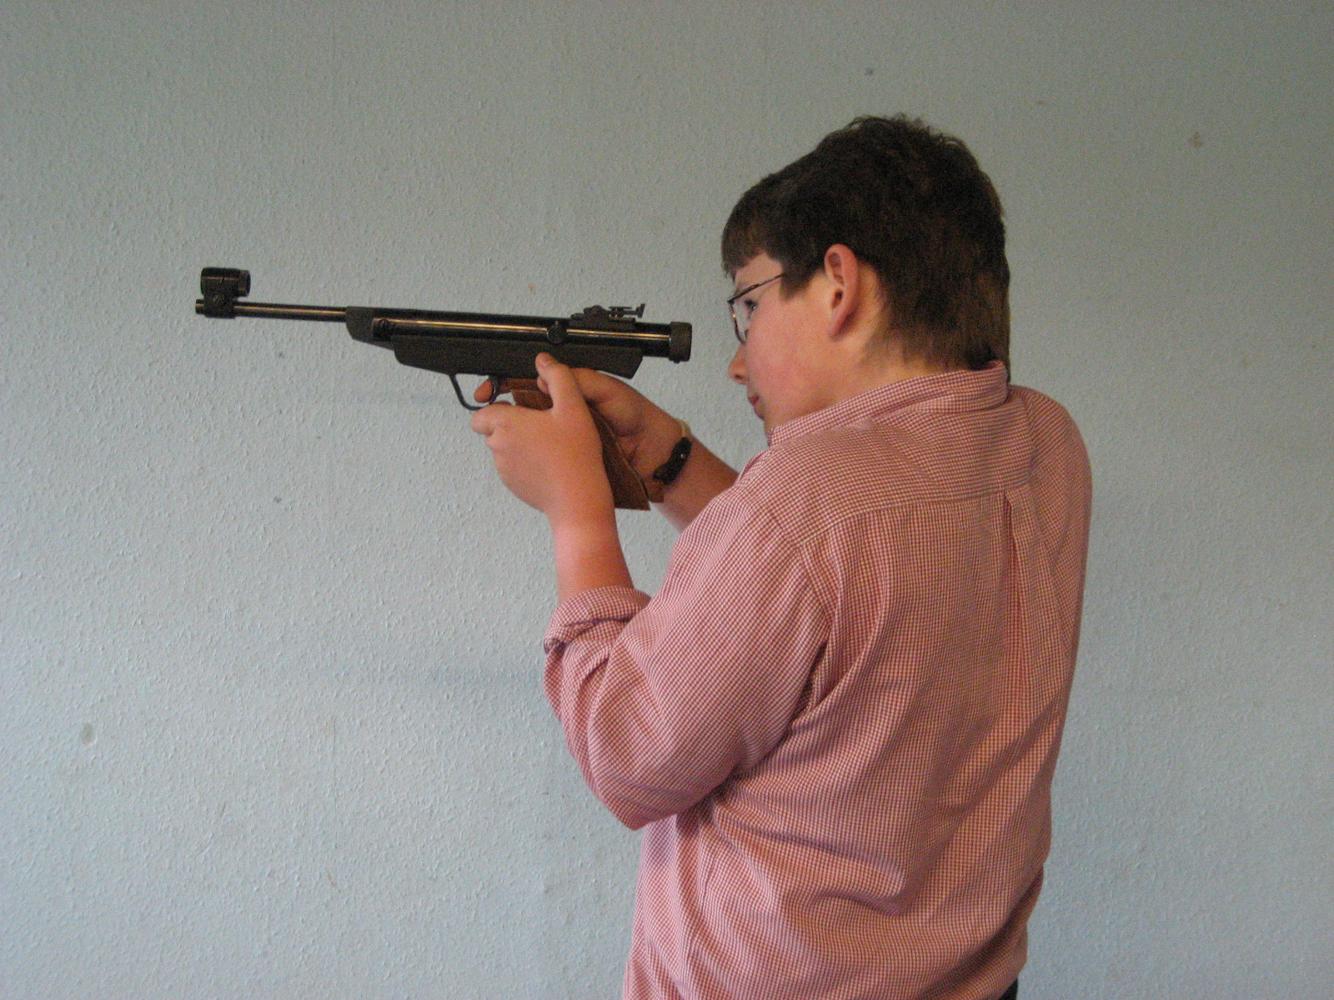
An unacceptable position with the hand in front of the trigger guard….
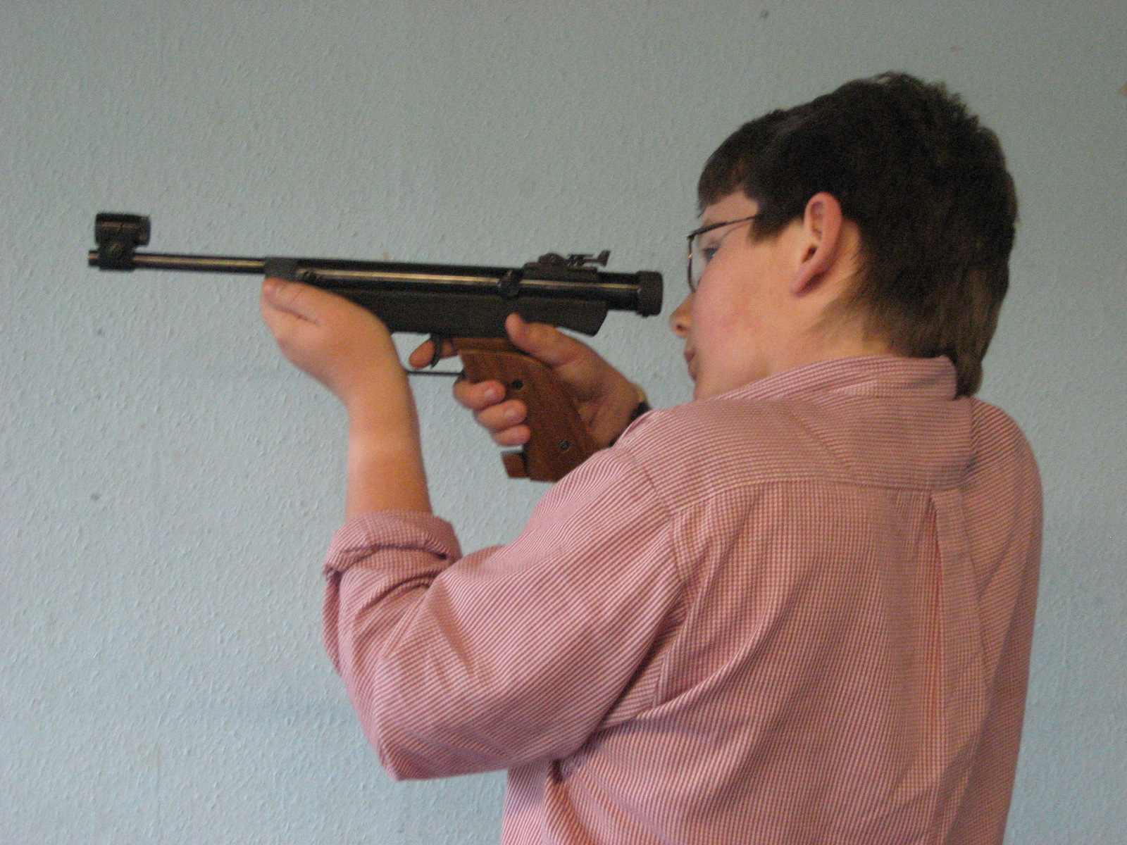

5.6 The match. Marked targets ( with stickers attached) are sent out for the first three teams entered by any school. Each team member fires five shots at each of two targets. Sighting shots on a separate target are allowed. Please write the estimated score on each competition card and send the targets with a score register to the address given.

The deadlines for receipt of the targets are: 15th December, 25th March and 10th July.

6, Divisions.

The trophies awarded are the Lord Lloyd of Kilgerran Shields.

6.1 Purpose. Divisions are intended to give an added interest to all schools which enter regularly for the St. Patrick's and St. David's Shields. They are recommended particularly for Schools that have just started shooting and those who, because of circumstances, feel that they are unlikely to win a major trophy. They do not interfere with these competitions and the main trophies can be won by any team irrespective of whether in a division or not.

6.2 Membership. Schools indicate whether they wish to be placed in a division - an option open only to those who intend to return scores in at least two terms out of the three. For a term in which a school is known by its entry not to be competing, the previous term's score will be credited. This 'floating score' will appear in brackets on the results list. A school which fails to return a score when it has entered to do so will be dropped from the divisions for the rest of the year. If some unexpected disaster strikes then inform the Competitions Secretary before the deadline date and ask for an emergency float.

6.3 Organisation. Each division, except sometimes the lowest, contains at least four teams, the first team only from each school. The winners of divisions 2 and 3 each receive a Lord Lloyd Shield. They also move up to join the higher division for the coming term and are shown on the results list with a 'U' for Up. The team at the bottom of each division moves down and this is shown with a 'D'. A team cannot win a division with a 'floating score' but can be relegated with it

6.4 Scores. For division purposes only, the best six scores will count in the 3rd and 4th divisions. The full VIII scores are, of course, needed for the main shield competition, and in these divisions the score registers should show both the VIII and the best 6 scores. For teams in the 1st and 2nd divisions all eight scores count.

A full set of eight Winners' certificates will be awarded, even to those teams which win with a 'best 6' score.

7. Proficiency Certificates.

7.1 The targets used are the same as those for the competitions and all the rules laid down for the competitions must be observed except that the targets are scored internally by the shooting instructor. There is no age limit imposed on those attempting to attain certificates A declaration to shoot for a certificate must be made, and the target named, before starting to shoot.
The qualifying scores for all certificates are based on the aggregate of the required number of targets, ( 2, 3 or 4 ). Should the firer fail or decides to “stop” then all previous scores are canceled and cannot be “carried over”. In such cases a new series of targets should be started and a fresh attempt made.

The series of shots must be fired consecutively but not necessarily on the same day. Sighting shots on another target are permitted if they are an integral part of the nominated shoot.

7.2 For .22 rifles: 30 shots are fired at three targets.

The qualifying scores are: Mastershot 285 out of 300
Marksman 275
First Class 260
Second Class 225

7.3 For .177 air rifles: if the set of three different targets used for competitions is regarded as a series, the Mastershot Certificate requires three series comprising 30 shots, the other certificates require just two series and 20 shots.

The qualifying scores are: Mastershot 255 out of 300
Marksman 150 out of 200
First Class 120
Second Class 80

7.4 For air pistols: 20 shots are fired, 5 shots at each target.

The qualifying scores are: Mastershot 190 out of 200
Marksman 185
First Class 170
Second Class 140

Certificates can be purchased from the Secretary. Please order five or more certificates at a time.

8. The National Smallbore Rifle Association, (NSRA)

The PSRA is affiliated to the NSRA but all schools may join in their own right and for those using.22 rifles there are definite advantages, which include:

- Assistance with range construction or alteration. The NSRA is responsible for certifying all civilian small bore ranges. Contact them for advice on all matters.

b) The supply of shooting requirements.

c) Insurance cover is included with affiliation.

d) The NSRA offer a number of coaching and Range Officer courses for those who would like to gain higher qualifications. Further details may be had by writing to them.

e) The Junior NSRA competitions and the St. Piran's Cup for the leading preparatory school in the Under 15 section.

Our .22 rules are intended, in general, to conform with those of the NSRA. The NSRA's address is:

Lord Roberts Centre,
Bisley Camp,
Brookwood,
Woking, Surrey.
GU24 ONP.

Telephone: 01483 485505
Fax: 01483 476392
Email: info@nsra.co.uk

9. PSRA Contact addresses and phone numbers.

These are updated as necessary in each PSRA Newsletter:

Chairman C.H. Laughton,
St. Andrew's School,
Meads, Tel. 01323 733203
Eastbourne, Fax. 01323 646860
E. Sussex, BN20 7RP. E-mail: claughton@androvian.com

Secretary Mrs Mary Eveleigh,
E-mail: PSRASecretary@gmail.com

Interim Treasurer. C.H. Laughton.
Address as above.

Competitions Secretary, C.H. Laughton,
(.22 rifle, .177 Air rifle Address as above.
and air pistol). Cheques made payable to 'PSRA'.

Proficiency Certificates Mrs M. Eveleigh,
contact by e-mail as above.
Cheques payable to 'PSRA'

Range Officer Certificate. N.S.R.A.
.22 Rifle targets Lord Roberts Centre,
Air Rifle targets Bisley Camp, Brookwood, Tel. 01483 485505
Air Pistol targets. Woking, Surrey. GU24 ONP.

The following seven pages contain attached Appendices with various advice sheets which aim to provide useful information on Shooting in Prep Schools.

APPENDIX 1
THE PREPARATORY SCHOOLS RIFLE ASSOCIATION.

HOW TO START SHOOTING.

The first decision is, will you use .22 cartridge rifles, or .177 air rifles, and/or .177 air pistols.
.22 cartridge rifles

For cartridge rifles, it is necessary to obtain Home Office approval for your range. This can only be done through the National Small-bore Rifle Association, so the first move must be to contact and join the NSRA (Lord Roberts Centre, Bisley Camp, Brookwood, Woking, Surrey GU24 ONP).

The NSRA can supply a booklet, Construction of Ranges for .22 Rifles, and advice on the required procedures.

You will probably want a 25 yard range, but if necessary 20 yards will do. A further 6 or 7 yards is needed for the firing point. The NSRA's booklet explains the required size of the stop butt wall and other safety requirements. The NSRA will also be able to advise you as to the various stages of planning and approval that will be required in order to build a new facility. When the NSRA has certified the range as safe it will issue a certificate of Home Office approval under the Firearms Act.

A Range Safety certificate does not have an expiry date ( unlike that for Home Office Approval ) provided that the range remains unaltered in its specification. It is vital however that you contact the NSRA if you propose to make any changes to an existing range as these may well violate your Range Safety Certificate. Work can only begin once the NSRA has approved your proposed modifications.

If any difficulties are met, please seek advice by contacting the Chairman of the PSRA.

Air Rifles.

For .177 air rifles, the requirements are much simpler and cheaper and no official approval is required.
A range of 10 yards is needed, measured from the front edge of the firing point to the target face. The stop butt should be 5 feet high and extend 2 1/2 feet on either side of the outside targets. The stop butt should be made of 1" planks, and a brick wall should be faced with the same depth of wood. The target holders can be the type of pellet stopper sold by gunsmiths to take the NSRA's AIR 3/89 target. (Size = 170mm x 170mm). You may be able to find a blacksmith who will make an angled backplate which will deflect pellets downwards.

For the firing point, each firer needs about 2 1/2 feet of space, either flat on the floor or on a slightly sloping platform. The centre of the targets should be about an inch below the eye level of the shooter.

Air Pistol
For .177 air pistols a range of 6 yards is needed. The target holders should be fixed at the eye-level of the (standing) firer and the stop butt must be protected with a non-ricochet surface. Suitable materials are either insulation board or old carpet extending to at least 2’ 6” on all sides surrounding the target centres. The wearing of eye protection is strongly advised.

At the firing point, a table or bench must be placed in front of the firer. They may place their foot up to a mark on the floor representing 6 yards from the target face but not touching the table.
For further information, contact C. Laughton, Chairman PSRA, St Andrew’s School, Eastbourne, BN20 7RP.

APPENDIX 2

The Preparatory Schools Rifle Association

RULES for a .22 RANGE.

The term "range officer" means the member of staff, over the age of 21, approved by the Headmaster for the conduct of the range. The PSRA requires that this person is a qualified Range Officer; that is to say that they must have obtained their NSRA Range Officer Certificate. Please re-read paragraphs 1.6 and 1.7 on page 3.

1. Security.

  - The range is to be kept locked (or, if outside, out of bounds) at all times. No pupil is to enter the range until told to do so by the range officer.

  - Rifles must be kept locked in a secure place and must be moved only under the direct supervision of the range officer. The bolts of the rifles should be removed for storage and kept locked separately from the rifles.

  - Ammunition must be kept locked, separately from the rifles, and must be taken to and from the firing point by the range officer personally.

2. Before Firing

  - When the rifles are being carried, the breach must be open and the muzzle must be pointed at the ground. A gun must NEVER be pointed at a person.

  - Ammunition will be issued only on the firing point.
No pupil may have or handle any live round, misfire or empty cartridge case except on the firing point.

2.3 Ear protectors must be worn by all pupils all the time that they are on the range.

3. On the Firing Point.

  - A rifle may never be loaded except at the firing point, on the order of the range officer, with the muzzle pointing towards the targets A rifle may not be fired in any direction except at the target.

3.2 The following actions will take place ONLY on the direct order of the range officer:
a) Take position on the firing point, or leave it ( to the rear).
b) Load and fire.
c) Go forward to change targets.

4. After Firing

4.1 When all the firers have fired their allotted rounds, the range officer will:
a) Check that each rifle is unloaded, with the breach open,
- Collect all empty cases, together with any misfires and live rounds, and check that these equal the number of rounds issued.

  - The hands must always be washed after shooting, to guard against lead pollution.
APPENDIX 3.

The Preparatory Schools Rifle Association

RULES for an AIR RIFLE RANGE.

The term "range officer" means the member of staff, over the age of 21, approved by the Headmaster for the conduct of the range. The PSRA requires that this person is a qualified Range Officer; that is to say that they must have obtained their NSRA Range Officer Certificate. Please re-read paragraphs 1.6 and 1.7 on page 3.

1. Security.

1.1 The range is to be kept locked (or if outside, out of bounds) at all times. No pupil is to enter the range until told to do so by the range officer.

1.2 Rifles must be kept locked in a secure place and must be moved only under the direct supervision of the range officer. Pellets are to be kept locked, in a separate place from the rifles.

2. Before Firing.

2.1.When a rifle is being carried, it must be "made safe" by breaking the barrel without cocking the gun (or, where appropriate, by opening the loading tap). Except on the firing point, the muzzle of the rifle must be pointed at the ground.

A gun must NEVER be pointed at a person.

3. On the Firing Point

  - A rifle may never be loaded except on the firing point, on the order of the range officer, with the muzzle pointing towards the targets. A rifle may not be fired in any direction except at the target.

  - The following actions will take place ONLY on the direct order of the range officer:

a) Take position on the firing point, or leave it (to the rear).
b) Load and fire.
c) Go forward to change targets.

4. After Firing.

4.1 When the firers are ready, the Range Officer will check that every rifle has been "made safe" before giving the order to move off the firing point.

4.2 At the end of the shooting session, the range officer will check that each rifle is unloaded and "made safe", and is not cocked, before it is locked away.

  - The hands must always be washed after shooting, to guard against lead pollution.

APPENDIX 4.

The Preparatory Schools Rifle Association

RULES for an AIR PISTOL RANGE.

The term "range officer" means the member of staff, over the age of 21, approved by the Headmaster for the conduct of the range. The PSRA requires that this person is a qualified Range Officer; that is to say that they must have obtained their NSRA Range Officer Certificate. Please re-read paragraphs 1.6 and 1.7 on page 3.

- Security.

  - The range is to be kept locked (or, if outside, out of bounds) at all times. No pupil is to enter the range until told to do so by the range officer.
  - Pistols must be kept locked in a secure place and must be moved only under the direct supervision of the range officer. Pellets are to be kept locked, in a separate place from the pistols.

- Before Firing.

  - When a pistol is to be carried, it must first be "made safe" by breaking the barrel without cocking the pistol (or by opening the bolt or cocking lever) and must be carried with the muzzle pointing towards the ground.
A pistol must NEVER be pointed at a person.

2.2 The wearing of some form of eye protection is strongly advised.

3. On the Firing Point.

3.1 A table should be placed in front of the foremost point where the firer may place his foot (six yards from the target face). A chair should be placed behind each firer. The bottom of the target should be four feet from the floor.
3.2 Before firing, the pistol must be placed on the table, in the safe position, with the muzzle pointing towards the target. During a detail, the pistol must either be in the hand and pointing towards the target, or be laid upon the table.
  - While cocking and loading the pistol, the muzzle must remain pointing in a safe direction. When closing the barrel (etc) after loading, the firer must ensure that neither hand nor finger covers the muzzle, and that the trigger is not touched.
  - The orthodox hold for a pistol is to grip it with one or both hands at arms length, with elbows straight. No part of the hand should be in front of the trigger guard.
  - When standing in the firing position, no part of the body may touch the table.
  - A pistol may never be loaded except at the firing point, on the order of the range officer, with the muzzle pointing in a safe direction. A pistol may not be fired in any direction except at the targets.
  - The following actions will take place ONLY on the direct order of the range officer:
a) Take position at the firing point, or leave it,
b) Load and fire,
c) Go forward to change targets.

- After Firing:
4.1 Make the pistol safe, lay it on the table, step back and sit down.
4.2 The range officer will check that each pistol is neither cocked nor loaded before it is put away.
4.3 The hands must always be washed after shooting to guard against lead pollution.

APPENDIX 5.

THE PREPARATORY SCHOOLS RIFLE ASSOCIATION.

SHOOTING LAW as it applies to MINORS.

This brief summary of the Law as it relates to minors who shoot represents the bare minimum that shooting coaches and their charges should know. These notes should however be treated as no more than guides to a complex subject. Further advice may be had by contacting the Firearms Officer at your County Police Headquarters.

1. It is an offence in law for any person under the age of 17 to buy or hire any firearm or ammunition. This includes air guns ( air rifles/air pistols ) and the pellets for them.

2. It is an offence to give or part with possession of a firearm (including air rifles or air pistols) to a person under 14, except under supervision as explained below. It is therefore not possible in law for a parent to give an air rifle to a child under 14. Any such rifle or pistol remains the property of the parent, to be used under supervision only.
A person over 14 but under17 may use a firearm without supervision, or own one, but may not buy one.

3. A person under 14 may not handle or use any firearm, except:

a) On a shooting range under supervision.

- With respect to air guns only, while under the supervision of a person over the age of 21.
Thus a child may not use an air rifle or air pistol in his own garden without supervision.

4. A missile fired on land where one has permission to shoot may not travel beyond the boundaries of that land.

5. In a public place (including in a car on a road) a firearm must be securely fastened in a case.

6. As young people under 14 can use a .22 rifle only on a range, where the person in charge must have a Firearms Certificate, the question of a Firearms Certificate for the child does not arise.
Over the age of 14, young people need a personal Firearms Certificate if they shoot anywhere other than on a range, with a .22 cartridge rifle.
No Firearms Certificate is required for any normal air rifle or air pistol.

APPENDIX 6.

The Preparatory Schools Rifle Association

Protection from DEAFNESS on .22 ranges.

The PSRA's rules require that ear protectors must be worn for any .22 shooting under our rules; and we earnestly recommend that ear protectors should ALWAYS be worn by everyone while on the range.

The Ministry of Defence makes the wearing of ear protectors compulsory on all ranges under its control.

One of our member schools has been involved in a court case concerning loss of hearing from exposure to rifle noise. This underlines the need to take this problem very seriously.

Noise Induced Hearing Loss is caused by exposure to the 'crack' of rifle fire, particularly from .22 rifles. It affects the frequencies between 3 and 6 kHz, and the first warning is a failure to hear a watch ticking and similarly high-pitched sounds. Eventually the loss of the high notes makes for difficulty in distinguishing speech when in a group.

The condition cannot be reversed and must therefore be prevented.

Ear plugs can be used, such as the NSRA's Lee Sonic Ear Valves or the Amplivox Gunfender, but ear plugs can convey infection if exchanged between pupils. Properly adjusted ear muffs are probably better.

Home-made ear plugs such as cotton wool are useless.

WE URGE that your HEADMASTER should read this.

APPENDIX 7.

The Preparatory Schools Rifle Association

APPLICATION for a CERTIFICATE as RANGE OFFICER.

1. Send £10.00 to the NSRA (Lord Roberts House, Bisley Camp, Brookwood, Woking, Surrey. GU24 ONP) and ask for their pamphlet "Range Control". You will need one pamphlet (and fee) for each applicant.

2. Study the check-list below and sign it. If you do not have any of the documents mentioned, ask the Secretary, PSRA (address, see No 4. below).
3. Add the serial number of your copy of the NSRA pamphlet.

4. Get your Headmaster to sign the form and apply to PSRASecretary@gmail.com for the postal address

Mrs M. Eveleigh, Secretary PSRA,
E-mail: PSRASecretary@gmail.com

..................................................................................................................................................

I certify that I have read and studied the following documents (please tick)

1. The NSRA pamphlet "Range Control." .....................

2. The PSRA’s Rules( 2012) .....................

3. The PSRA's recommended Range Rules for the weapon(s) you use ......................
(see appendices 2,3 and 4 in Rule Book)

4. The PSRA leaflet on "The Law" (appendix 5 in the Rule Book) .....................

Serial number on the "Range Control" pamphlet, .....................

I declare as Headmaster of this school that the applicant named above is a member of my staff, has at least one year’s experience of teaching and has demonstrated the necessary capability and knowledge to conduct a range.

Signature of Headmaster .......................................................................

NAME OF SCHOOL .......................................................................

DATE ………................................................................

